*******************1******************************

**What do we use Try with resourse?**

* Support for try-with-resources — introduced in Java 7 — allows us to declare resources to be used in a try block with the assurance that the resources will be closed after the execution of that block.
* The resources declared need to implement the AutoCloseable interface.

Note-Before Java 9, we could only use fresh variables inside a *try-with-resources*block:

**try** (**Scanner** scanner = **new** **Scanner**(**new** **File**("testRead.txt"));

**PrintWriter** writer = **new** **PrintWriter**(**new** **File**("testWrite.txt"))) {

// omitted

}

As of Java 9 and as part of [JEP 213](https://openjdk.java.net/jeps/213), **we can now use**[***final*or even effectively final**](https://www.baeldung.com/java-effectively-final)**variables inside a *try-with-resources*block**:

**final** **Scanner** scanner = **new** **Scanner**(**new** **File**("testRead.txt"));

**PrintWriter** writer = **new** **PrintWriter**(**new** **File**("testWrite.txt"))

**try** (scanner;writer) {

// omitted

}

********************2**************************

**What is Chaining Of Exception?**

Ans-

* In Java, a chained exception is a technique that enables programmers to associate one Exception with another.
* By providing additional information about a specific exception, debugging can be made easier.
* A chained exception is created by wrapping an existing exception in a new exception, which becomes the root cause of the new Exception.

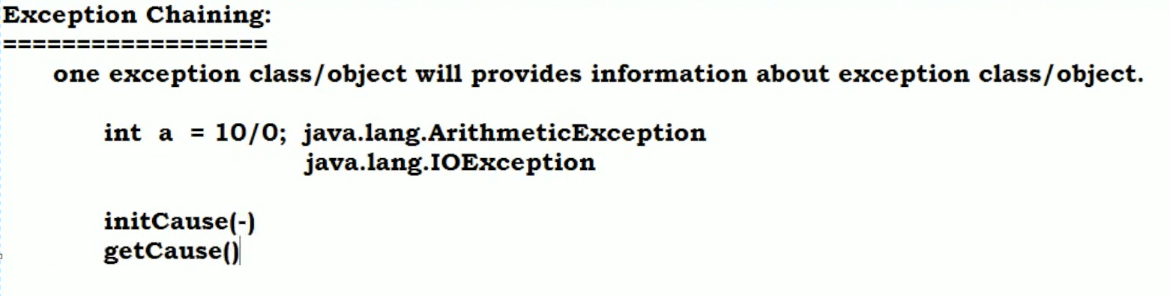

**Difference Between non chained and chained Exception**

|  |  |
| --- | --- |
| **Non-chained exceptions** | **Chained exceptions** |
| An exception occurs and is caught at the point where it occurs without any reference to the original cause of the Exception. | The original cause of the Exception is preserved and reported along with the current Exception. |
| A lack of reference to the original cause can make debugging and troubleshooting more challenging. | Chained exceptions provide more context to the Exception and make it easier to identify and fix the root cause of the problem. |
| Suitable for small programs or simple systems where exceptions are limited and easy to identify | Particularly useful in large programs or complex systems where exceptions can be thrown across different components, as it can help identify where the problem first occurred and how it propagated through the system |

**-----------------------Demo On Chaining--------------------------------**

**package com.cg.exception;**

**import java.io.File;**

**import java.io.FileNotFoundException;**

**import java.util.Scanner;**

**class Calculator**

**{**

**public void checkPositiveNumber(int num) throws Throwable**

**{**

**try{**

**if (num < 0)**

**{**

**throw new IllegalArgumentException("Number must be positive");**

**}**

**else**

**{**

**int result = 100 / num;**

**System.out.println(" Division Result: " + result);**

**}**

**}**

**catch (IllegalArgumentException e)**

**{**

**//by default if u use printstack it prints run time information**

**//e.printStackTrace();**

**throw e.initCause(new NegativeNumberException("Number should not be negative"));**

**}**

**catch (ArithmeticException e) {**

**// create a new exception with the original Exception as the cause**

**throw new RuntimeException("Error: division by zero", e);**

**}**

**}**

**}**

**public class TestCalculator**

**{**

**/*public static void main(String[] args)**

**{**

**Scanner scanner = new Scanner(System.in);**

**System.out.print("Enter a positive integer: ");**

**int num = scanner.nextInt();**

**Calculator cc=new Calculator();**

**try {**

**cc.checkPositiveNumber(num);**

**} catch (Throwable e) {**

**System.out.println(" Please chk numberif negative :"+e.getMessage());**

**}**

**scanner.close();**

**}**

**\*/**

**//--------------try with resource-----**

**/\***

**\* public static void main(String[] args)**

**{**

**Scanner scanner=null;**

**try**

**{**

**scanner = new Scanner(new File("text.java"));**

**}**

**catch (FileNotFoundException e1)**

**{**

**// TODO Auto-generated catch block**

**e1.printStackTrace();**

**}**

**System.out.print("Enter a positive integer: ");**

**int num = scanner.nextInt();**

**Calculator cc=new Calculator();**

**try**

**{**

**cc.checkPositiveNumber(num);**

**} catch (Throwable e) {**

**System.out.println(" Please chk numberif negative :"+e.getMessage());**

**}**

**finally**

**{**

**scanner.close();**

**}**

**}**

**}*/**

**public static void main(String[] args)**

**{**

**try(Scanner scanner = new Scanner(new File("test.txt")))**

**{**

**System.out.print("Enter a positive integer: ");**

**int num = scanner.nextInt();**

**Calculator cc=new Calculator();**

**try**

**{**

**cc.checkPositiveNumber(num);**

**}**

**catch (Throwable e)**

**{**

**System.out.println(" Please chk numberif negative :"+e.getMessage());**

**}**

**}**

**catch (FileNotFoundException e1)**

**{**

**e1.printStackTrace();**

**} }}**

*****************3***********************

**What changes are done in Java 8 Hashmap? How it works internally**

Ans-

* HashMap use LinkedList internally

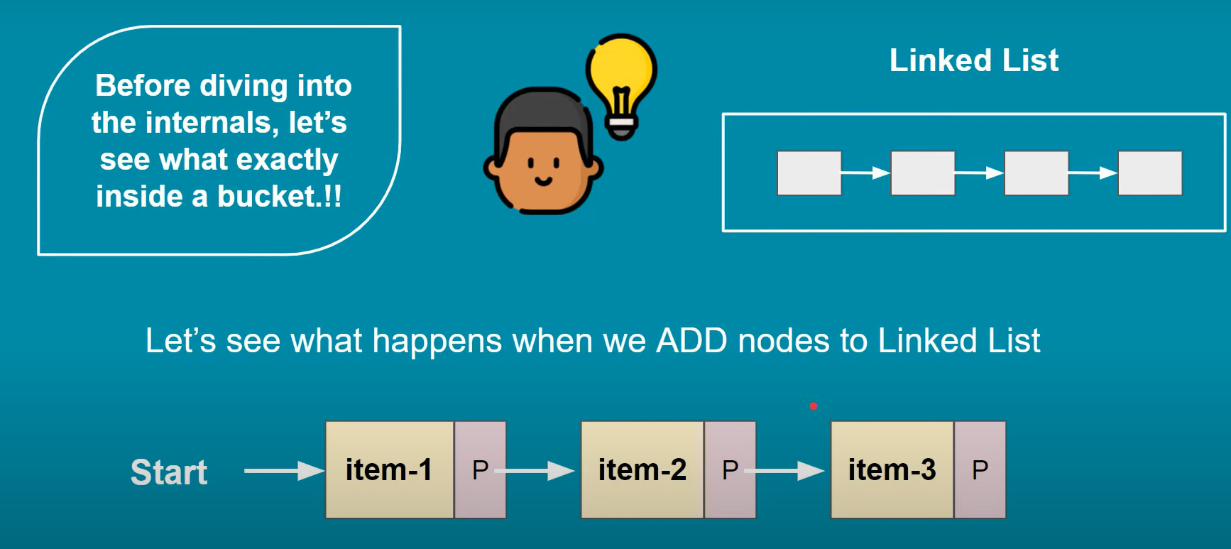

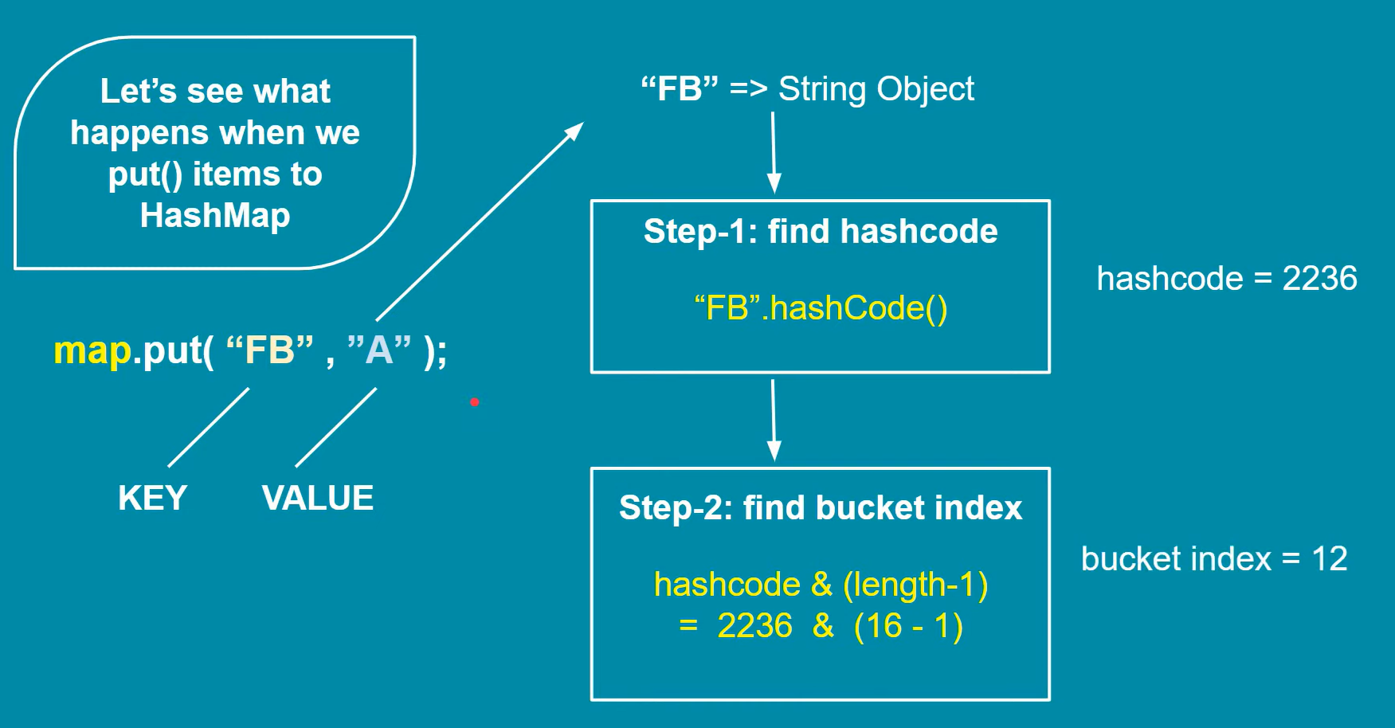

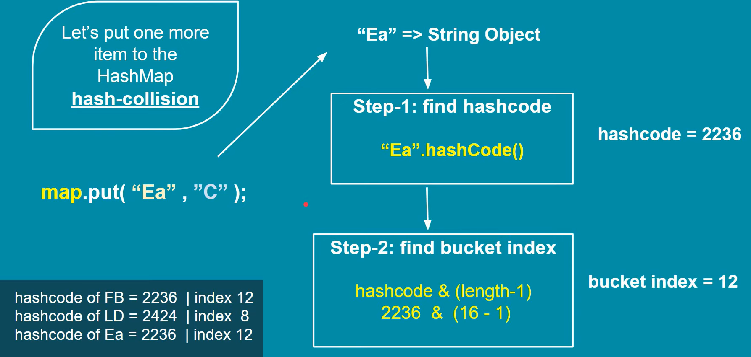

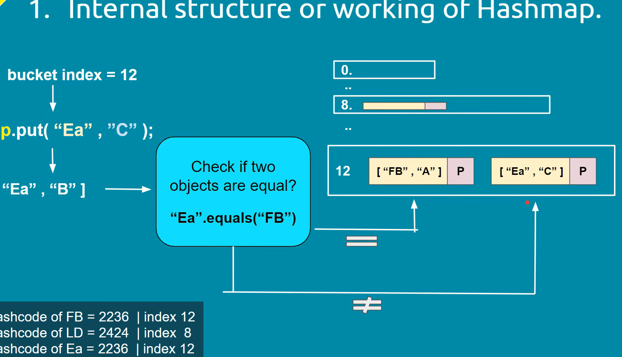

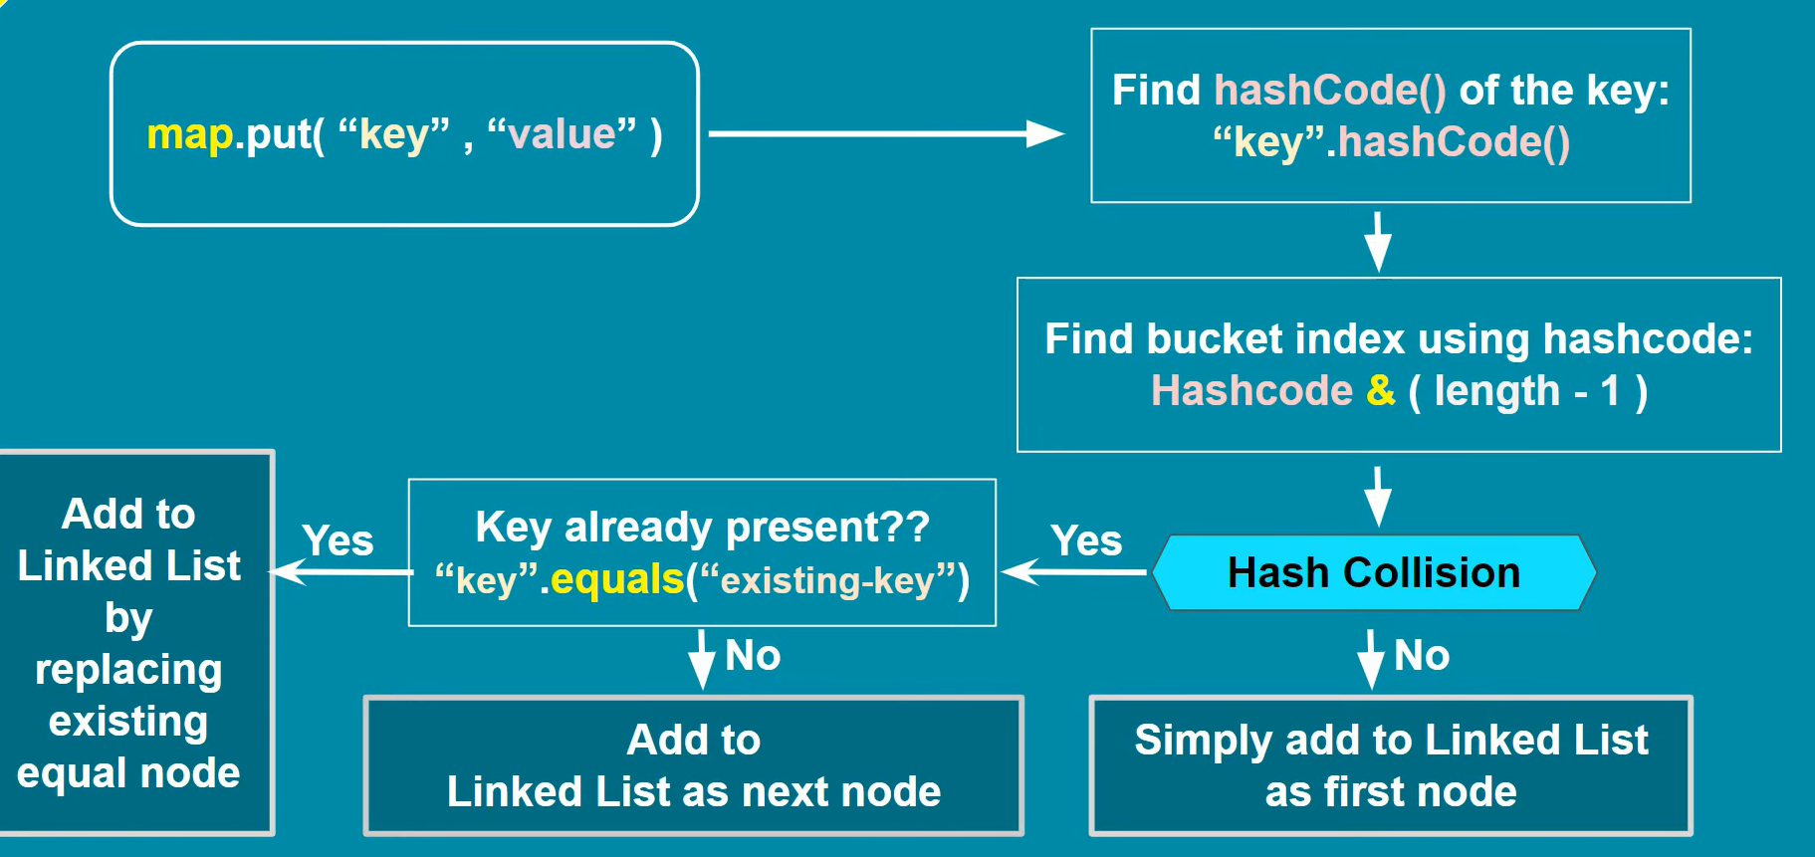

* Hash collision might happen.
* But JVM uses equals function and at 12th index position it store third entry as second node
* Problem with search operation in Hashmap is ,it start searching from first node unnecessary

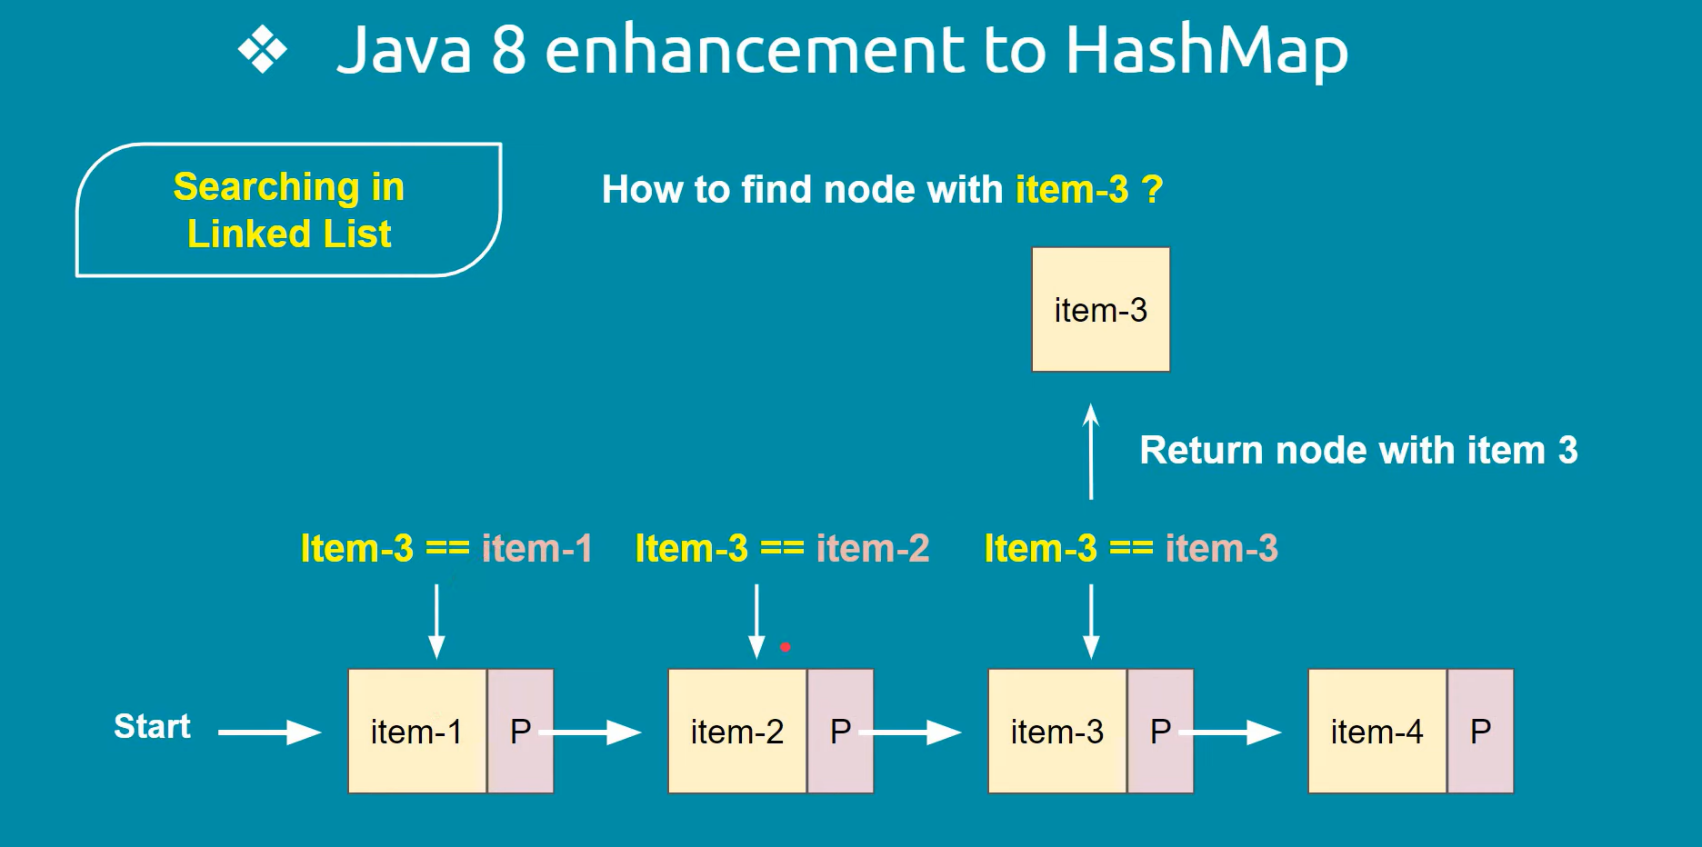

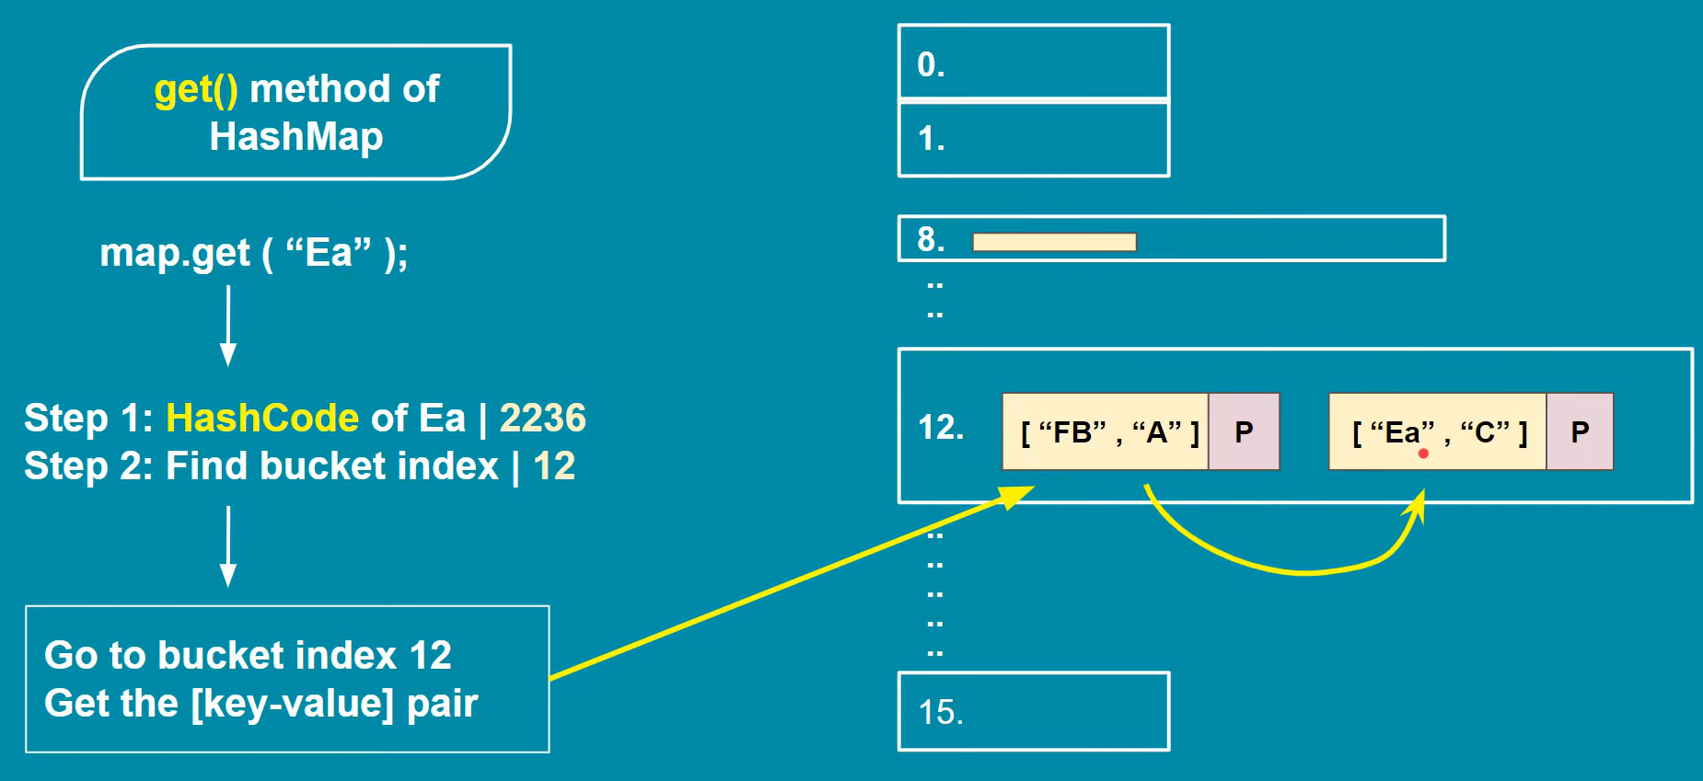

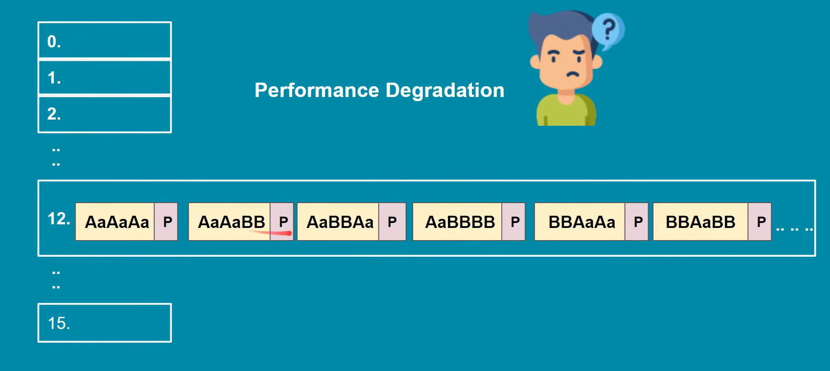

* To enhance the performance for above case in HashMap in Java 8 they have converted Linked list in Tree when it reaches to some threshold

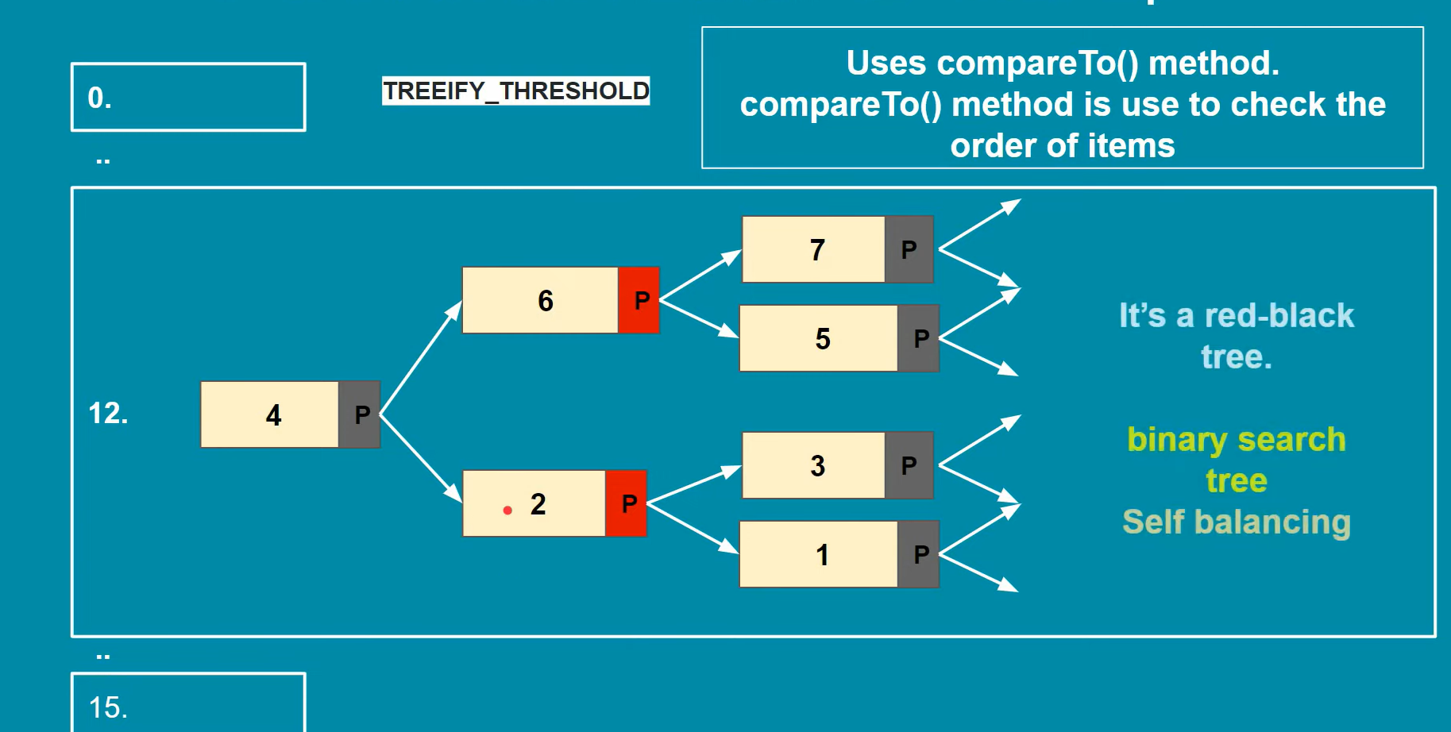

--------------------------Demo-------------------------

**package** com.cg.exception;

**import** java.util.HashMap;

**public** **class** TestHashMapDemo {

**public** **static** **void** main(String[] args) {

HashMap<String,String> hm=**new** HashMap<String,String>();

System.***out***.println(" HashCode For FB "+"FB".hashCode());

System.***out***.println(" HashCode For LD "+"LD".hashCode());

System.***out***.println(" HashCode For Ea "+"Ea".hashCode());

//Here we can have hash collision

hm.put("FB", "A");

hm.put("LD", "B");

hm.put("Ea", "C");

System.***out***.println(hm);

}

}

**\*\*\*\*\*\*\*\*\*\*\*4\*\*\*\*\*\*\*\*\*\*\*\*\*\*\*\*\*\*\*\***

**Why default and static method is provided in interface in new version of java?**

Ans-

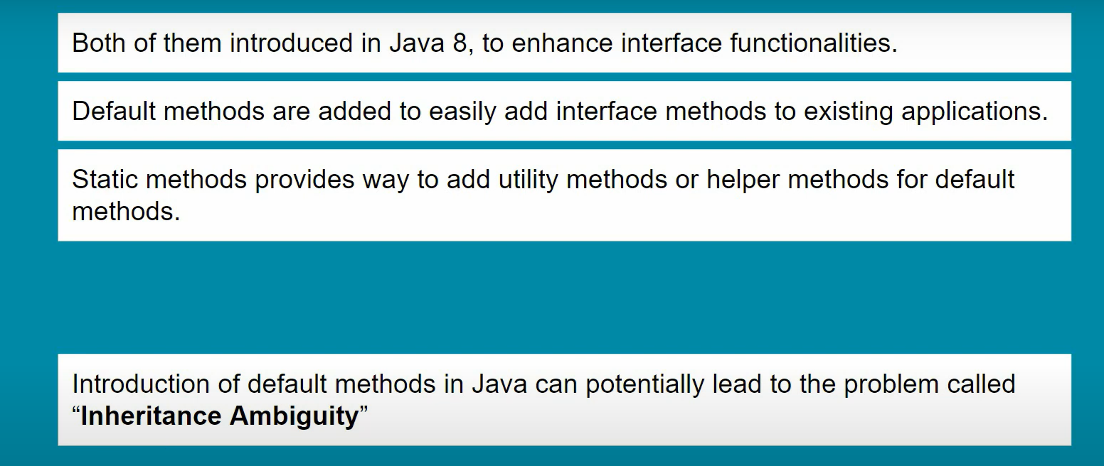

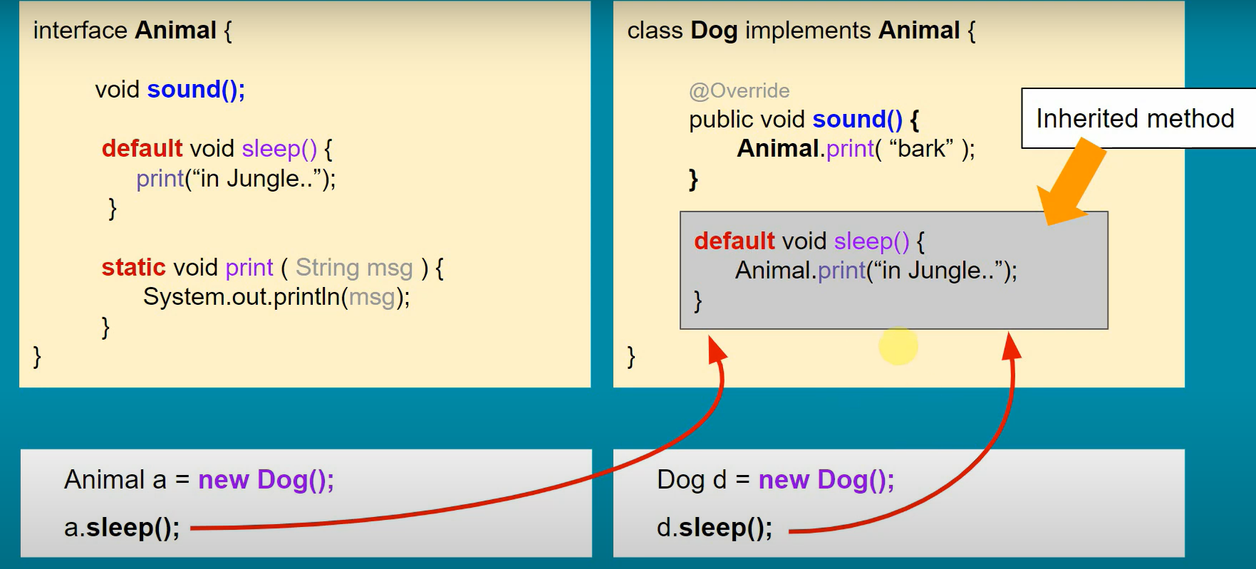

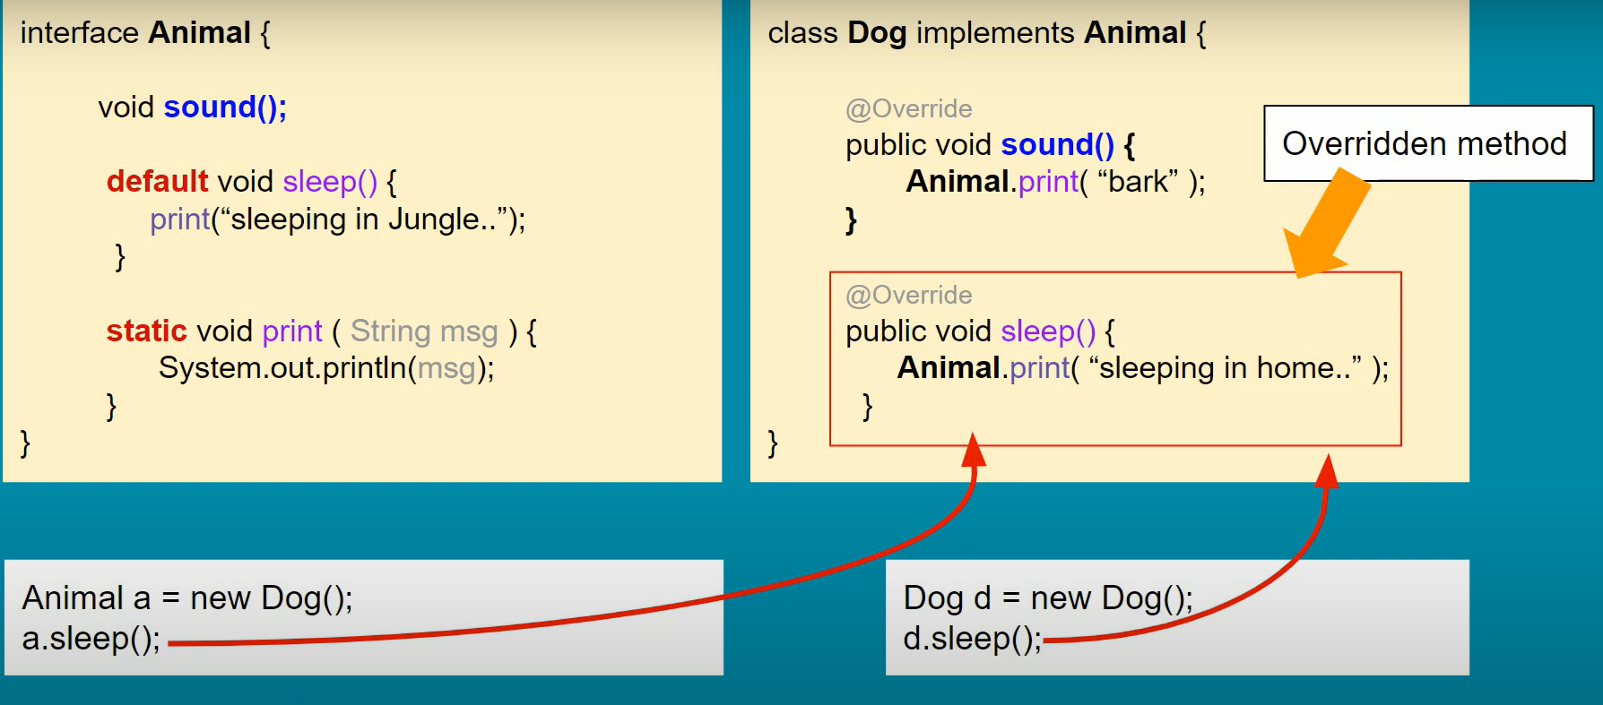

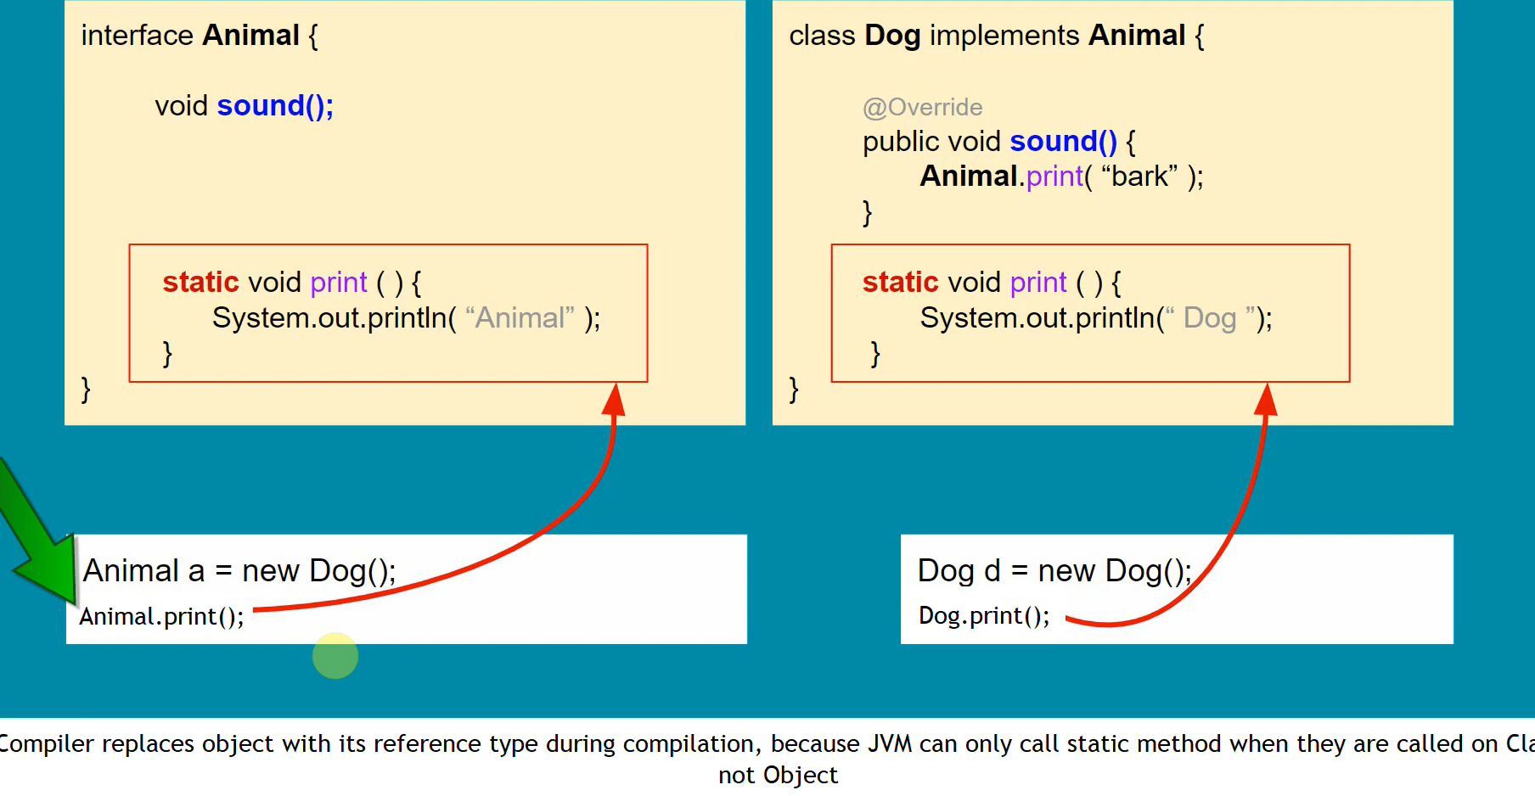

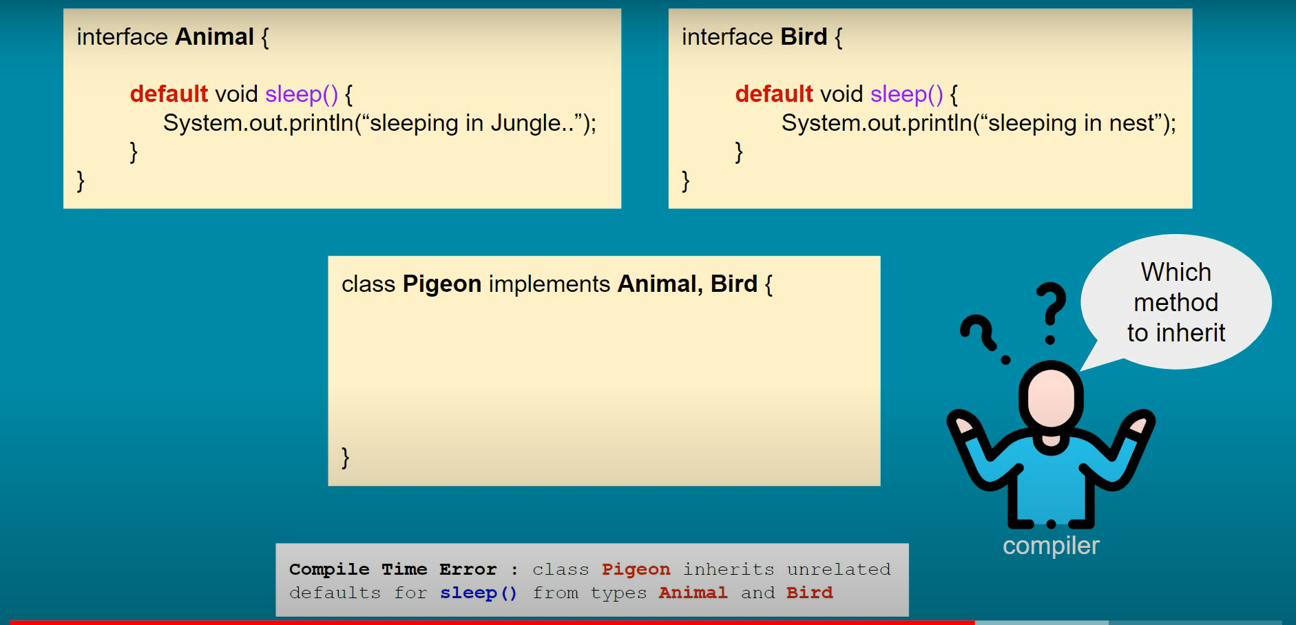

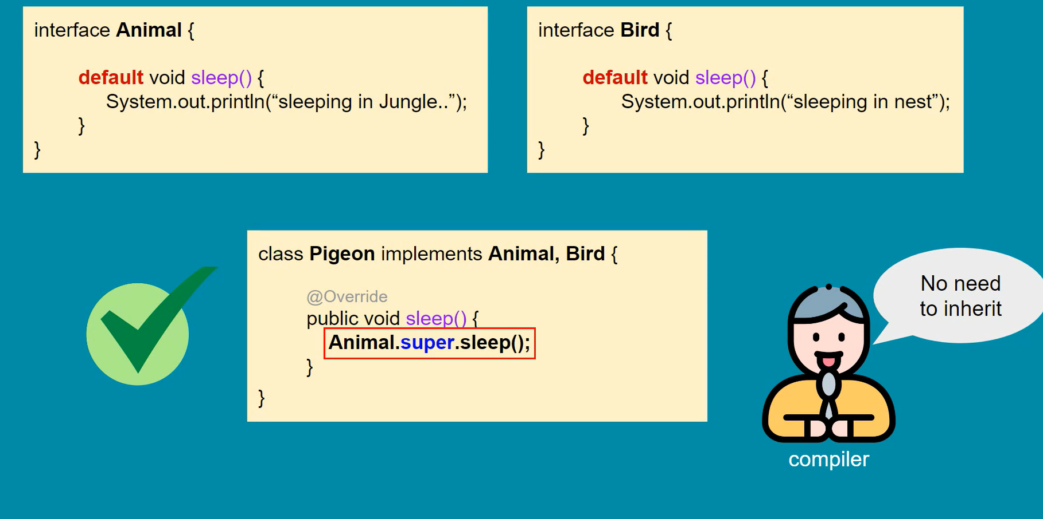

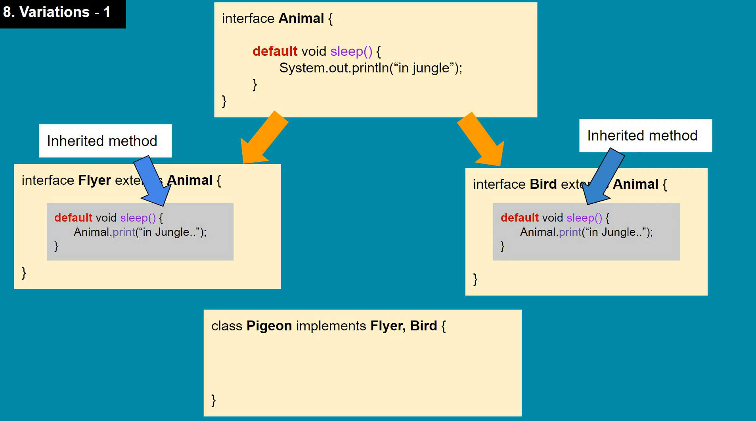

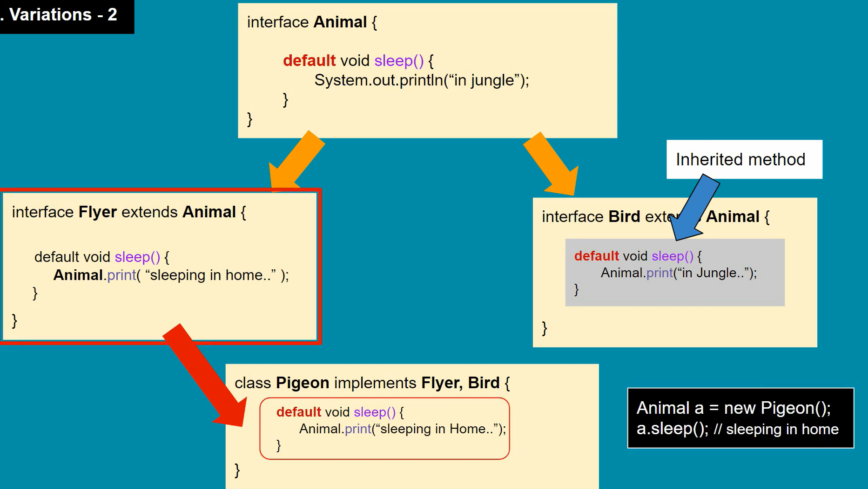

***************5*****************************

**What are– intermediate -terminate operation**?

Ans- 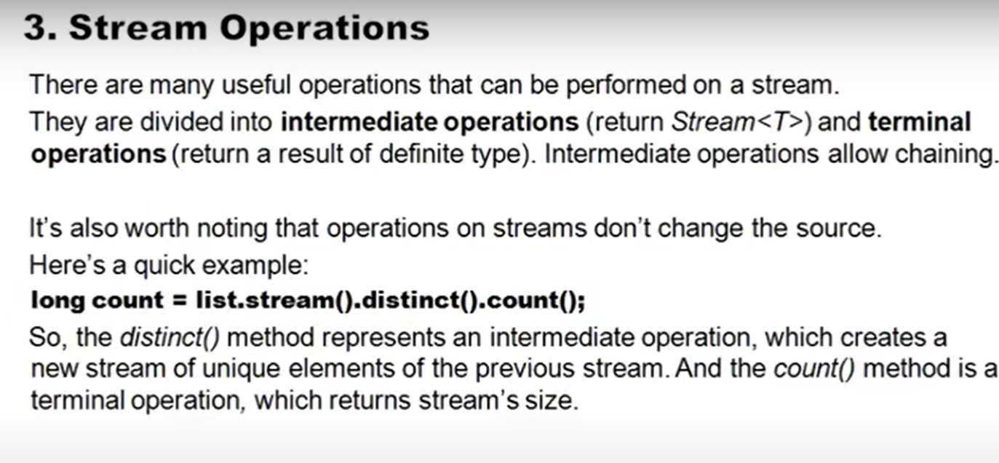

**************7***************************

What are Java 8 features

* Lambda expressions,
* Method references,
* Functional interfaces,
* Terminators API,
* Default methods,
* Base64 Encode Decode,
* Static methods in interface,
* Optional class,
* Collectors class,
* ForEach() method,
* Parallel array sorting,
* Nashorn JavaScript Engine,
* Parallel Array Sorting,
* Type and Repating Annotations,
* IO Enhancements,
* Concurrency Enhancements,
* JDBC Enhancements etc

*****************8************************

# **What are Anonymous Classes?**

* Anonymous classes enable you to make your code more concise. They enable you to declare and instantiate a class at the same time.
* They are like local classes except that they do not have a name. Use them if you need to use a local class only once.

**\*\*\*\*\*\*\*\*\*\*\*\*\*\*\*\*\*\*\*\*\*\*\*\*\*\*\*\*9\*\*\*\*\*\*\*\*\*\*\*\*\*\*\*\*\*\***

## Why Lambda Expressions?

* Lambda expression helps us to write our code in functional style. It provides a clear and concise way to implement SAM interface(Single Abstract Method) by using an expression.
* It is very useful in collection library in which it helps to iterate, filter and extract data.
* One issue with anonymous classes is that if the implementation of your anonymous class is very simple, such as an interface that contains only one method, then the syntax of anonymous classes may seem unwieldy and unclear.
* In these cases, you're usually trying to pass functionality as an argument to another method, such as what action should be taken when someone clicks a button.
* Lambda expressions enable you to do this, to treat functionality as method argument, or code as data.
* Anonymous class is often more concise than a named class, for classes with only one method, even an anonymous class seems a bit excessive and cumbersome.
* Lambda expressions let you express instances of single-method classes more compactly.

**\*\*\*\*\*\*\*\*\*\*\*\*\*\*\*\*\*\*\*\*10\*\*\*\*\*\*\*\*\*\*\*\*\*\*\*\*\*\*\*\***

## What is Method References in Java 8?

* Java 8 Method reference is used to refer method of functional interface . It is compact and easy form of lambda expression. Each time when you are using lambda expression to just referring a method, you can replace your lambda expression with method reference.
* You use [lambda expressions](https://docs.oracle.com/javase/tutorial/java/javaOO/lambdaexpressions.html) to create anonymous methods. Sometimes, however, a lambda expression does nothing but call an existing method. In those cases, it's often clearer to refer to the existing method by name. Method references enable you to do this; they are compact, easy-to-read lambda expressions for methods that already have a name.

**\*\*\*\*\*\*\*\*\*\*\*\*\*\*\*\*\*11\*\*\*\*\*\*\*\*\*\*\*\*\*\*\*\*\*\*\*\*\*\*\*\*\*\***

**What is Copy Constructor?**

* In Java, a copy constructor is a special type of constructor that creates an object using another object of the same Java class. It returns a duplicate copy of an existing object of the class.
* We can assign a value to the final field but the same cannot be done while using the clone() method. It is used if we want to create a deep copy of an existing object. It is easier to implement in comparison to the clone() method.
* Note: It cannot be inherited by the subclasses. If we try to initialize a child class object from a parent class reference, we face the casting problem when cloning it with the copy constructor.

**********************12*****************************

**What is the Use of Copy Constructor**

We can use the copy constructor if we want to:

* Create a copy of an object that has multiple fields.
* Generate a deep copy of the heavy objects.
* Avoid the use of the Object.clone() method.

Advantages of Copy Constructor

* If a field declared as final, the copy constructor can change it.
* There is no need for typecasting.
* Its use is easier if an object has several fields.
* Addition of field to the class is easy because of it. We need to change only in the copy constructor.

**\*\*\*\*\*\*\*\*\*\*\*\*\*\*How To Create Copy Constructor\*\*\*\*\*\*\*\*\*\*\*\*\*\*\*\***

* To create a copy constructor in Java, follow the steps given below:
* Create a constructor that accepts an object of the same class as a parameter.

**public** **class** Fruits

{

**private** **double** price;

**private** String name;

//copy constructor

**public** Fruits(Fruits fruits)

{

//getters

}

}

Copy each field (variable) object into the newly created instance.

**public** **class** Fruits

{

**private** **double** price;

**private** String name;

//copy constructor

**public** Fruits(Fruits fruits)

{

//copying each filed

**this**.price = fruits.price; //getter

**this**.name = fruits.name; //getter

}

}

Example of Copy Constructor

**CopyConstructorExample.java**

**public** **class** Fruit

{

**private** **double** fprice;

**private** String fname;

//constructor to initialize roll number and name of the student

Fruit(**double** fPrice, String fName)

{

fprice = fPrice;

fname = fName;

}

//creating a copy constructor

Fruit(Fruit fruit)

{

System.out.println("\nAfter invoking the Copy Constructor:\n");

fprice = fruit.fprice;

fname = fruit.fname;

}

//creating a method that returns the price of the fruit

**double** showPrice()

{

**return** fprice;

}

//creating a method that returns the name of the fruit

String showName()

{

**return** fname;

}

//class to create student object and print roll number and name of the student

**public** **static** **void** main(String args[])

{

Fruit f1 = **new** Fruit(399, "Ruby Roman Grapes");

System.out.println("Name of the first fruit: "+ f1.showName());

System.out.println("Price of the first fruit: "+ f1.showPrice());

//passing the parameters to the copy constructor

Fruit f2 = **new** Fruit(f1);

System.out.println("Name of the second fruit: "+ f2.showName());

System.out.println("Price of the second fruit: "+ f2.showPrice());

}

}

**\*\*\*\*\*\*\*\*\*\*\*\*\*\*\*\*\*\*\*\*\*13\*\*\*\*\*\*\*\*\*\*\*\*\*\*\*\*\*\*\*\*\*\*\***

**What is the difference between Copy Constructor Vs clone() Method**

* Both the copy constructor and the clone() method are used to create a copy of an existing object of the class. But the use of copy constructor is easier and better in comparison to the clone() method because of the reasons given below:
* If we are using the clone() method it is necessary to import the **Cloneable** The method may throw the exception **CloneNotSupportException.** So, handling the exception in a program is a complex task. While in copy constructor there are no such complexities.
* We cannot assign a value if the fields are **final**. While in the copy constructor we can assign values to the final fields.
* The object returned by the clone() method must be **typecast**. While in copy constructor there is no such requirement.

*******************13**************************

**What are the best practices on garbage collection?**

**Ans-**

**\*\*\*\*\*\*\*\*\*\*\*\*\*\*\*\*\*\*\*\*\*\*14\*\*\*\*\*\*\*\*\*\*\*\*\*\*\*\*\*\*\*\*\***

**What is the difference between Serial & Throughput Garbage Collector?**

**Ans**

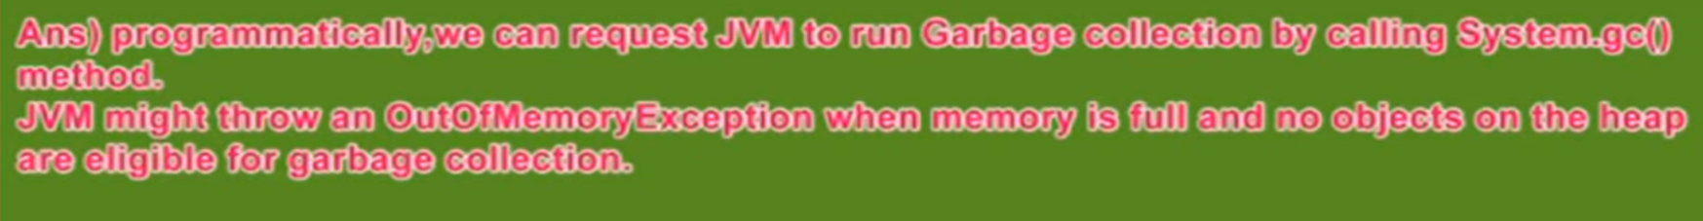

**\*\*\*\*\*\*\*\*\*\*\*\*\*\*\*\*\*\*\*\*\*\*\*\*\*15\*\*\*\*\*\*\*\*\*\*\*\*\*\*\*\*\*\*\***

**What is Ragged Array?**

**Ans-**

In [computer science](https://en.wikipedia.org/wiki/Computer_science), a **jagged array**, also known as a **ragged array** [[1]](https://en.wikipedia.org/wiki/Jagged_array#cite_note-1) or **irregular array**  is an [array](https://en.wikipedia.org/wiki/Array_data_structure) of arrays of which the member arrays can be of different lengths, producing rows of jagged edges when visualized as output. In contrast, two-dimensional arrays are always rectangular[[4]](https://en.wikipedia.org/wiki/Jagged_array#cite_note-Box2002-4) so jagged arrays should not be confused with [multidimensional arrays](https://en.wikipedia.org/wiki/Array_data_type), but the former is often used to emulate the latter.

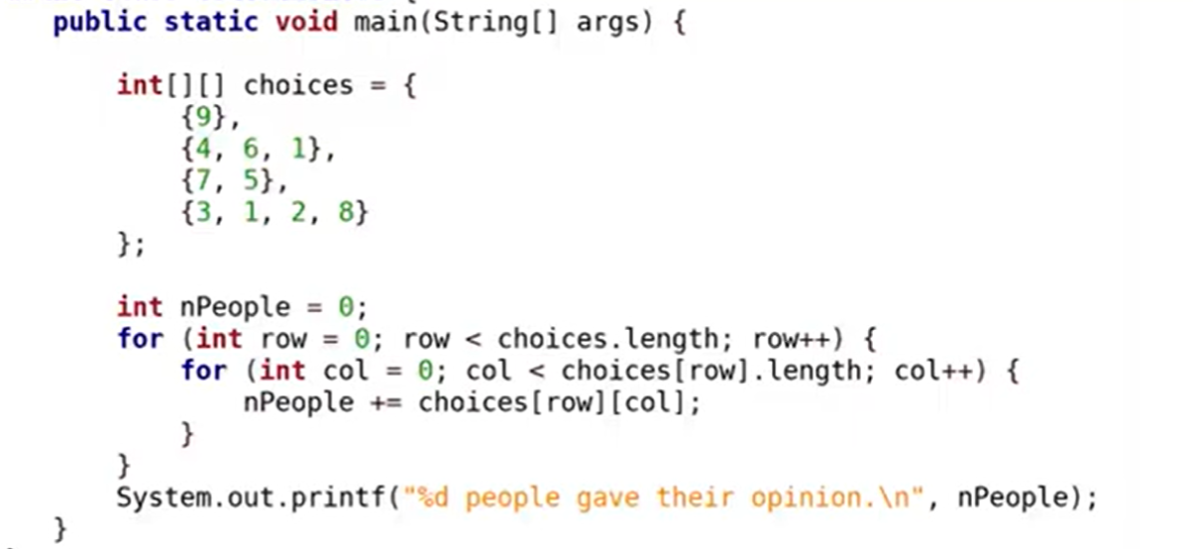

**\*\*\*\*\*\*\*\*\*\*\*\*\*\*\*\*\*\*\*\*\*\*\*16\*\*\*\*\*\*\*\*\*\*\*\*\*\*\*\*\*\*\*\*\*\*\*\*\***

**Is it possible to make an Array Volatile?**

**Ans-**

Yes, you can make the array volatile but that will only cover change to the reference variable pointing to an array, it will not cover changes in individual array elements.